**ỦY BAN NHÂN DÂN QUẬN TÂN BÌNH  
TRƯỜNG TH PHẠM VĂN HAI**

**BÀI ÔN SỐ 1 – MÔN TIẾNG ANH – KHỐI 5**

**A.KIẾN THỨC NGỮ PHÁP :**

**HAVE TO – HAD TO**

**1.HAVE TO (hiện tại):**

|  |  |  |
| --- | --- | --- |
|  | **Ý nghĩa** | **Ví dụ** |
| **Have to +** động từ ở dạng nguyên mẫu | nói về một việc gì đó chúng ta nên làm. | It’s late. We **have to** leave now. |
| muốn chỉ đường cho ai đó | You **have to** go left at the traffic lights. |

**2.HAD TO (quá khứ):**

|  |  |  |
| --- | --- | --- |
|  | **Ý nghĩa** | **Ví dụ** |
| **Had to +** động từ ở dạng nguyên mẫu | nói về một việc gì đó chúng ta nên làm trong quá khứ. | They **had to** go over the bridge. |

**B.BÀI TẬP**

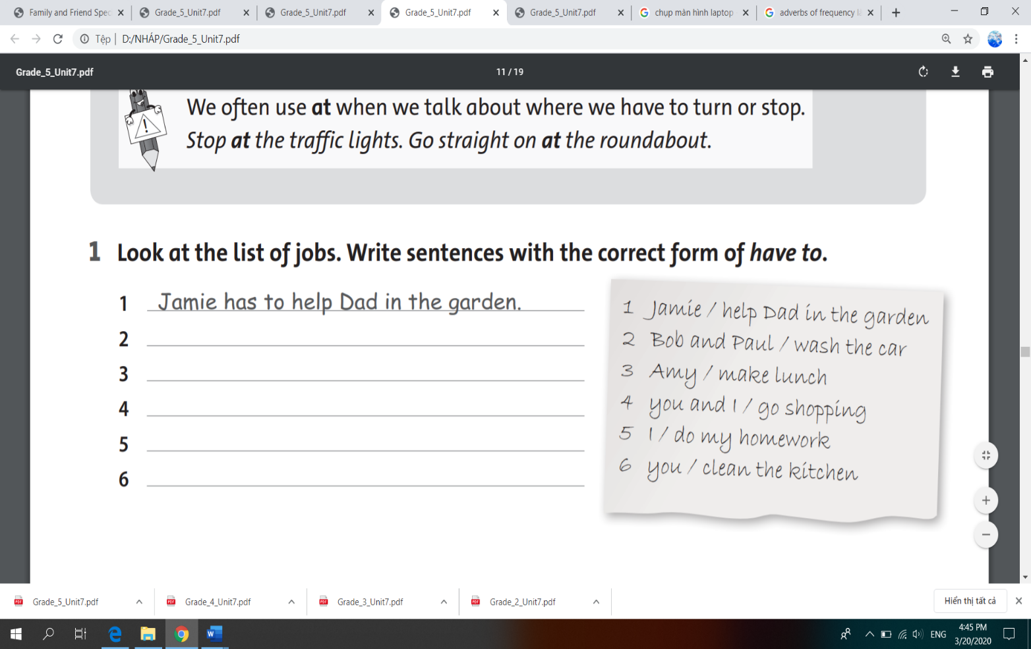**I. Look at the list of jobs. Write sentences with the correct form of have to:**

|  |  |
| --- | --- |
| 1 | Jamie has to help Dad in the garden. |
| 2 | ___________________________________ |
| 3 | ___________________________________ |
| 4 | ___________________________________ |
| 5 | ___________________________________ |
| 6 | ___________________________________ |

**II. Complete the conversation. Use have to and the verb in brackets.**

|  |  |
| --- | --- |
| **Anna:** | Excuse me. Where’s the cinema? |
| **Mr Lee:** | You 1________________ (go) straight on for 200 metres. Then, you 2________________ (turn) left. At the roundabout, you  3________________ (turn) right. |
| **Anna:** | OK, thanks. |
| **Mr Lee:** | No, wait. You 4________________ (go) over the railway line. |
| **Anna:** | Yes, I know it. The cinema’s by the petrol station. |
| **Mr Lee:** | No, you 5________________ (go) past the petrol station. The cinema’s another500 metres. |

**III. Look at the map. Give directions from the school to the Science Museum.**

**Use have to and the words from the box.**

go straight on go over turn left turn right go straight on

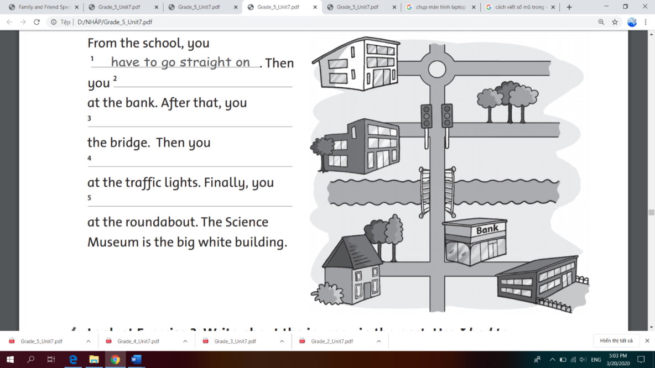

From the school, you have to go straight on. Then   
you 2 ________________ at the bank. After that, you   
3________________ the bridge. Then you 4________________  
at the traffic lights. Finally, you 5________________ at the roundabout. The Science Museum is the big white building.

**IV. Look at Exercise 3. Write about the journey in the past. Use I had to**

1. First, *I had to go straight on.*
2. Then, ______________________________________________________
3. After that, ___________________________________________________
4. Then, _______________________________________________________
5. Finally, _____________________________________________________